# CHATBOT FOR HANDLING ACADEMIC QUERIES

### A SEMINAR REPORT

Submitted by

### MUHAMMED AMAN T. K. KMC21CS031

**To**

### APJ ABDUL KALAM TECHNOLOGICAL UNIVERSITY

*In the partial fulfillment of the requirements for the award of the Degree*

*Of*

***Bachelor of Technology In***

***Computer Science & Engineering***



### KMCT COLLEGE OF ENGINEERING

**Kallanthode, Calicut**

Department of Computer Science & Engineering

2024-2025

# DECLARATION

I undersigned hereby declare that the seminar report **“CHATBOT FOR HANDLING ACADEMIC QUERIES”**, submitted for partial fulfillment of the requirements for the award of degree of Bachelor of Technology of the APJ Abdul Kalam Technological University, Kerala is a bonafide work done by me under supervision of **Mrs. Najiya Nasrin K.** This submission represents my ideas in my own words and where ideas or words of others have been included, I have adequately and accurately cited and referenced the original sources. I also declare that I have adhered to ethics of academic honesty and integrity and have not misrepresented or fabricated any data or idea or fact or source in my submission. I understand that any violation of the above will be a cause for disciplinary action by the institute and or the University and can also evoke penal action from the sources which have thus not been properly cited or from whom proper permission has not been obtained. This report has not been previously formed the basis for the award of any degree, diploma or similar title of any other University.

Date: 07/11/24

Place: Kallanthode

### MUHAMMED AMAN T.K

# KMCT COLLEGE OF ENGINEERING, KALLANTHODE

**DEPARTMENT OF COMPUTER SCIENCE & ENGINEERING**

***(Affiliated to the APJ Abdul Kalam Technological University)***



**CERTIFICATE**

This is to certify the seminar report entitled **CHATBOT FOR HANDLING ACADEMIC QUERIES”** submitted by **MUHAMMED AMAN T. K. (KMC21CS031)** to the APJ Abdul Kalam Technological University in partial fulfillment of the requirements for the award of the Degree of Bachelors of Technology in Computer Science and Engineering is a bonafide record of seminar carried out by him under the guidance and supervision. This report in any form has not been submitted to any other University or Institute of any purpose.

Seminar Guide Seminar Coordinator Head of The Department

**Mrs. NAJIYA NASRIN K** **Mrs. NAJIYA NASRIN K**  **Dr.SREEKESH NAMBOODIRI T**

Assistant professor Assistant professor Associate professor

Dept of CSE Dept of CSE Dept of CSE

# ACKNOWLEDGMENT

I would remember with grateful appreciation the encouragement, guidance and support rendered by **Dr. SABIQ P V**, the Principal of KMCT College of Engineering, Calicut. I express my deepest sense of gratitude towards **Dr. SREEKESH NAMBOODIRI T**, Head of the Department Computer Science and Engineering for his valuable advice and guidance.

I also express my heartiest gratitude to the seminar coordinator **Mrs. NAJIYA NASRIN K**, Department Computer Science and Engineering for the timely suggestions and encouragement given for the successful completion of this seminar. I would always oblige for the helping hands of all other staff members of the department and all my friends and well wishers, who directly or indirectly contributed in this venture.

Last but not least, I am indebted to God Almighty for being the guiding light throughout this seminar and helped me to complete the same within the stipulated time.

### MUHAMMED AMAN T. K

# ABSTRACT

This report presents the development and functionality of "IntraBot," an intelligent chatbot designed to handle a wide range of academic queries. Leveraging Natural Language Processing (NLP) and Artificial Intelligence (AI), IntraBot provides instant access to essential academic information, such as student scores and attendance, directly through a mobile application interface. Unlike conventional web navigation, which is often hampered by re-login requirements and internet dependency, this chatbot offers offline functionality with a one-time login feature, thus enhancing user experience and efficiency.

IntraBot’s responses are powered by Rasa, an open-source conversational AI framework that ensures accurate interpretation of user intents and efficient generation of responses. Utilizing the Recurrent Neural Network (RNN) for intent recognition, IntraBot is adept at parsing diverse question formats, ensuring reliable and contextually relevant responses. By storing user data in a MySQL database and managing it through tokenization, IntraBot personalizes its responses for individual users, addressing academic needs in real-time.

Designed to be user-friendly and accessible, the chatbot is integrated with an easy-to-navigate Android interface implemented in Java and enhanced with additional Kotlin libraries. This application addresses the limitations of traditional systems by offering round-the-clock, personalized access to academic information, without requiring constant internet connectivity.

The IntraBot system highlights the evolving role of AI in educational support, setting a benchmark for time optimization in academic data retrieval. Future enhancements, such as integration with Google Cloud Maps, aim to extend the chatbot’s capabilities by providing contextual location-based assistance to users, thus enriching the overall academic support experience.

# CONTENTS

CHAPTER 1 : INTRODUCTION 01

CHAPTER 2 : LITERATURE REVIEW 03

CHAPTER 3 : METHODOLOGY 06

CHAPTER 4 :RESULT ANALYSIS 11

CHAPTER 5 : CONCLUSION AND FUTURE WORKS 14

APPENDIX A : REFERENCE viii

# LIST OF FIGURES

**Figure 3.2.1** : Workflow of the proposed chatbot for handling academic queries 7

**Figure 3.2.2** : Proposed System Overview 8

# ABBREVIATIONS

# 

AI - Artificial Intelligence

DNN - Deep Neural Network

NLP - N atural Language Proccesing

RNN - Recurrent Neural Network

UAT - User acceptance testing

# CHAPTER 1 INTRODUCTION

In academic institutions, students frequently need to access a wide range of information related to their academic performance, attendance, and general announcements. The ability to retrieve this information quickly and accurately is essential for students, as it impacts their daily schedules, academic preparedness, and overall productivity. However, traditional college information systems often fall short in delivering a smooth and efficient user experience. Typically accessed through web portals, these systems require users to log in multiple times, maintain continuous internet connectivity, and navigate extensively to locate specific information. Such limitations create significant frustration, especially for students who require rapid, seamless access to information not only during college hours but also outside of them, where quick access to data may be critical.

In the digital age, where information is expected to be available on-demand, the inefficiencies of these conventional systems are more pronounced than ever. Students accustomed to modern digital interfaces in other aspects of their lives find themselves constrained by outdated systems that fail to meet their needs for accessibility, speed, and user-friendliness. The need for a solution that bridges this gap between students and essential academic data is therefore paramount. Artificial Intelligence (AI) and Natural Language Processing (NLP) have proven instrumental in transforming multiple sectors by enabling systems to interact with users in a human-like manner. Chatbots, which rely on these technologies, are designed to simulate human conversations, interpreting user inputs and delivering responses that closely resemble human interactions. AI-powered chatbots are not only capable of providing rapid, context-aware answers but also offer 24/7 access, operating without the need for constant human intervention. This has led to their widespread adoption across industries like customer service, healthcare, and e-commerce, where they have demonstrated significant benefits in enhancing accessibility to information, streamlining processes, and improving overall user satisfaction.

The same principles that make chatbots invaluable in these sectors can also be applied within academic environments to create intelligent systems capable of handling academic queries in a fast and user- friendly way. A chatbot designed for academic settings could effectively eliminate many of the common obstacles associated with traditional college portals, providing

students with a reliable, efficient method of accessing their data. Furthermore, the conversational format of chatbots aligns well with students’ expectations of ease of use, providing a seamless experience that mimics the simplicity of messaging applications. Recognizing this potential, this project aims to develop "IntraBot," an intelligent chatbot specifically designed to handle a wide range of academic queries. By leveraging AI and NLP, IntraBot will empower students to retrieve essential information, such as grades, attendance records, and college announcements, directly through a conversational interface.

IntraBot’s design aims to improve the accessibility and convenience of academic information retrieval by incorporating several user-centric features. A one-time login option will reduce the need for repeated logins, allowing students to access the information they need without unnecessary interruptions. Offline accessibility will further enhance convenience, ensuring that students are not entirely reliant on internet connectivity to retrieve critical data. This capability not only improves accessibility but also aligns with the mobile-centric lifestyle of today’s students, who expect flexibility in accessing digital resources.

In addition to these accessibility features, IntraBot will be equipped to interpret different query formats, providing accurate, contextually relevant responses that are tailored to each student’s specific profile. By personalizing interactions based on individual profiles, IntraBot will deliver a more meaningful user experience, fostering greater satisfaction and trust in the system. This personalized approach ensures that students receive information that is specific to their needs, whether they are querying about attendance, grades, or upcoming events. IntraBot’s round-the-clock availability will provide students with continuous access to their data, alleviating the limitations of traditional systems that are dependent on office hours and web portal availability.

IntraBot aims to transform the way students interact with academic information systems, making information retrieval more efficient, accessible, and intuitive. By minimizing reliance on traditional, internet-dependent portals, IntraBot sets a new standard for academic support tools, one that aligns with the expectations of modern students and enhances their overall academic experience. This project not only addresses current challenges but also establishes a foundation for future enhancements, such as integrating real-time location-based information, further expanding IntraBot’s utility within the academic setting.

# CHAPTER 2

# LITERATURE REVIEW

**2.1 Designing an Interactive Chatbot for Educational Assistance using Rasa Framework Authors**: Sujata Deshmukh, Χenus Gonsalves

**Year**: 2023

This study provides an in-depth look at the design and development process of a chatbot specifically tailored for educational assistance, utilizing the powerful Rasa framework. Rasa, a highly flexible and open-source tool, allows developers to create conversational AI that understands and processes natural language, a capability critical for addressing the unique and varied queries that students often have. The primary focus of the study is on leveraging Natural Language Processing (NLP) capabilities to build a chatbot capable of interpreting and responding accurately to a wide range of academic questions, enhancing the accessibility of academic resources.The authors explore how intent recognition and entity extraction, key features within Rasa, are implemented to parse user queries effectively. Intent recognition helps the chatbot understand the purpose of each question, while entity extraction pinpoints specific details within a query, such as names, dates, or subjects. This enables the chatbot to provide accurate, real-time information on essential topics like academic schedules, course details, and individual student records. By addressing these queries efficiently, the chatbot offers an instant and reliable source of academic information, reducing students' dependence on manual searches and lengthy navigation through traditional portals.The research underscores the flexibility and adaptability of Rasa’s framework, especially in the context of educational assistance, where customization is vital to meet evolving academic needs.

Furthermore, the study emphasizes the importance of a user-friendly interface to enhance the student experience. By simplifying interactions and ensuring ease of use, the chatbot is positioned as a valuable educational tool, streamlining information retrieval for students and allowing academic institutions to provide more responsive and accessible support.

**2.2 Smart Chatbot for College Information Enquiry Using Deep Neural Network**

**Authors**:Channabasamma, Lakshmi Soumya P., Nooka Swetha, Mukkari Indu

**Year**: 2023

This paper details the development and implementation of a smart chatbot powered by Deep Neural Network (DNN) technology, specifically aimed at addressing college-related queries. The purpose of the chatbot is to efficiently handle common student inquiries, ranging from academic records and grades to admission procedures and upcoming campus events. By designing a chatbot that uses DNN, the authors were able to improve the system’s ability to understand and interpret a variety of student questions accurately and provide instant responses.One of the primary distinctions of this chatbot is its reliance on DNN technology, which enhances its ability to recognize complex patterns in language. Unlike traditional rule-based systems, which operate on predefined scripts and limited logic, the DNN-based approach allows the chatbot to analyze questions in a more nuanced way. This capability is essential for accurately processing varied queries and responding in a way that feels natural to the user. By leveraging DNN, the chatbot not only increases accuracy in understanding user inputs but also improves the quality of responses, creating a more conversational and human-like interaction.

The authors also explore the benefits of using DNN in educational environments, where students often require detailed and context-specific information. For example, a student might ask about specific course prerequisites or inquire about procedures for on-campus housing, both of which require accurate, contextually relevant responses. The DNN-powered chatbot is adept at adapting to these varied student needs, ensuring that users receive responses that are relevant and comprehensive.

In addition to improving user experience, the study emphasizes how a DNN-based chatbot can reduce the administrative workload on college staff. Routine queries that previously required direct support can now be handled autonomously by the chatbot, enabling students to access information quickly without waiting for a response from staff. This functionality transforms the chatbot into a reliable self- service tool that promotes operational efficiency within the institution, freeing up staff to focus on more complex, non-repetitive tasks. Overall, the authors conclude that integrating DNN into chatbot systems offers significant benefits for both students and educational institutions by providing a scalable, efficient, and user-friendly information access solution.

### 2.3 VOID: An Assistant (Chatbot) to Education Queries System

**Authors:** Debaissh Chakraborty, Anjana Mishra, Vikash Kumar, Saloni Singh, Harshita Hani

**Year:** 2022

VOID is an educational chatbot designed to address a wide range of student inquiries, serving as a valuable tool for navigating academic requirements within a college or university setting. This study highlights the chatbot's role as a versatile assistant capable of handling common queries, such as those related to course details, exam schedules, and academic resources like libraries or study materials. By providing students with quick and organized answers, VOID aims to enhance the accessibility of essential information that students frequently seek.

The chatbot is built using a rule-based approach combined with fundamental Natural Language Processing (NLP) techniques. This method enables VOID to deliver structured and reliable responses to frequently asked questions and standardized inquiries. Rule-based systems are highly efficient in educational environments where many queries follow predictable patterns; for example, students might often ask about registration deadlines, lecture timings, or campus facilities. By implementing predefined responses to these common questions, VOID ensures prompt and accurate assistance without the need for complex programming.

The authors emphasize the benefits of a rule-based approach, particularly its simplicity, which allows for straightforward implementation and maintenance. However, they also acknowledge some limitations. While rule-based systems work well for routine queries, they lack the flexibility needed to address more complex or nuanced questions that might require understanding context or intent beyond a fixed set of rules. In situations where queries are varied or personalized, the limitations of a rule-based chatbot become apparent, as it may struggle to deliver satisfactory answers.

Ultimately, VOID is presented as an efficient solution for handling routine educational queries. However, the study suggests that integrating more advanced, AI-driven techniques—such as machine learning or deep neural network could enhance the chatbot's adaptability, allowing it to manage complex interactions with greater accuracy and relevance.

# 

# CHAPTER 3

# METHODOLOGY

## 3.1 Project Design and Planning

The initial phase of the project centered on comprehensive design and planning, with particular emphasis on gathering requirements and selecting appropriate technologies. To build a chatbot that genuinely meets user needs, especially those of students, understanding their expectations was essential. Interviews with students and faculty members were conducted to determine the most valuable features and functionalities. Additionally, an in- depth analysis of existing academic portals helped to identify limitations, ensuring the chatbot could address those shortcomings. From these findings, key requirements emerged, such as providing seamless access to academic scores, attendance records, and college announcements, as well as 24/7 availability and personalized responses tailored to individual student profiles.

Based on these user requirements, technology selection became a strategic step in the project planning. The Rasa framework was chosen for its robust natural language processing capabilities, specifically in intent recognition and entity extraction, which would allow the chatbot to interpret and respond accurately to diverse user queries. For data storage and management, MySQL was selected to handle sensitive academic information, such as scores and attendance records. Additionally, Java and Kotlin were chosen to develop a reliable and accessible Android application, ensuring that the chatbot interface would be user-friendly and compatible with mobile devices, making academic assistance readily available on demand.

**3.2 System Architecture**

The chatbot’s architecture was designed to create a seamless user experience by integrating a responsive front-end interface with efficient backend processes. The high-level architecture is organized into three main layers: the User Interface Layer, the Backend Layer, and the AI/NLP Layer. The **User Interface Layer** consists of the Android application, which serves as the primary interface where students interact with the chatbot to make queries or requests. The **Backend Layer** is responsible for processing these requests, managing data storage, and generating responses.

Meanwhile, the **AI/NLP Layer** plays a crucial role in interpreting user queries, identifying intents, and generating relevant responses, ensuring that the chatbot can respond accurately to academic- related questions.

The data flow within the system begins when a user inputs a query through the mobile app. This query is sent to the backend, where it interacts with the AI/NLP layer to analyze and interpret the query. If necessary, the backend retrieves specific data from the database, such as attendance records or scores, and uses it to construct a response. Finally, the response is relayed back to the user through the mobile app, completing a smooth communication loop and providing the student with the requested information in real time.

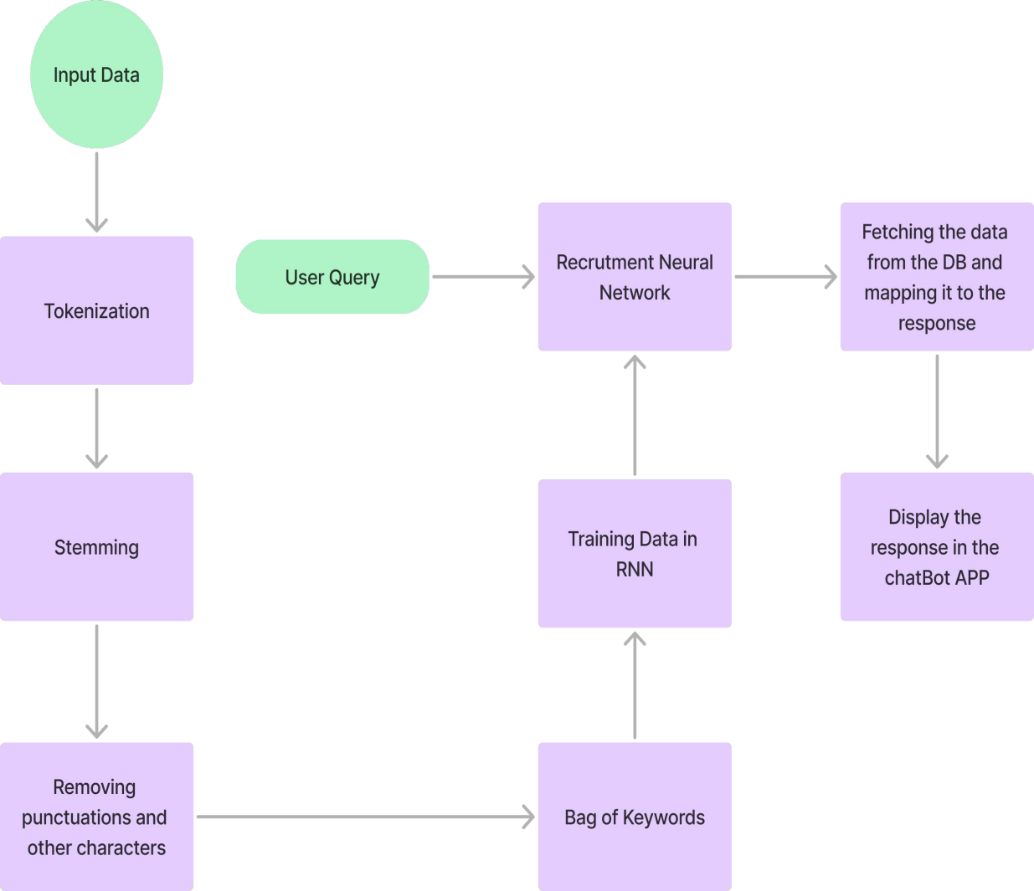

**3.2.1** Workflow of the proposed chatbot for handling academic queries

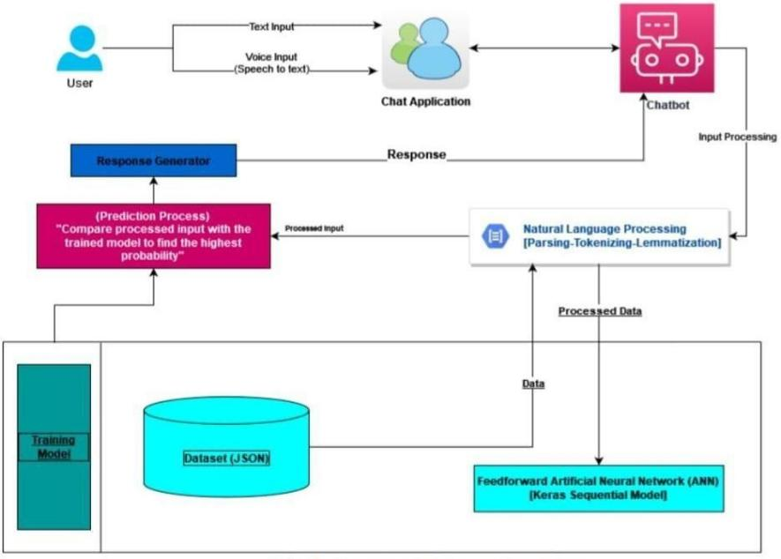

**3.2.2** Proposed System Overview

## 3.3 Chatbot Development

Rasa was implemented as the NLP framework to enable the chatbot to understand and respond to user queries with accuracy. The NLP model was designed to identify a variety of intents, including score inquiries, attendance checks, and general academic questions, which allows the chatbot to handle a broad range of academic-related queries. Entity extraction was integrated to refine responses further, enabling the chatbot to recognize and process specific details in user inputs, enhancing the relevance and personalization of its replies.

Training the NLP model involved compiling a dataset of sample dialogues based on common academic queries, ensuring it reflected real user interactions. The training process was iterative, involving continuous testing and improvements to enhance the model's intent recognition and entity extraction capabilities. By refining these aspects iteratively, the model was optimized to provide responses that were highly accurate, relevant, and aligned with user expectations, effectively tailoring the chatbot’s output to meet the specific needs of students.

Effective response generation is crucial for delivering a valuable user experience. Rasa’s dialog management system was configured to choose responses based on the detected intents, ensuring the responses were contextually appropriate. Two types of responses were developed:

personalized responses, which deliver tailored replies based on individual profiles, and a mix of static and dynamic responses. Static replies were used for frequently asked questions(FAQs), while dynamic responses were generated using real-time data from the database, ensuring the chatbot provided accurate and up-to-date information.

## 3.4 Mobile Application Development

The mobile application was developed with a user-friendly, intuitive design to ensure a seamless experience for students. Key user interface elements include a simple chat window, which serves as the primary area for interactions with the chatbot, displaying conversations in an organized and clear format. A one-time login screen enhances accessibility by minimizing repetitive logins, and information panels provide quick access to essential data, such as academic scores, attendance, and important announcements, making it easy for students to navigate the app.

To further enhance usability, offline accessibility was implemented to reduce reliance on a constant internet connection. By caching key data, such as recent scores and attendance records, the application allows students to access important academic information even without internet connectivity. This offline functionality ensures students have uninterrupted access to essential data, promoting a reliable and user-focused experience.

## 3.5 Data Management and Security

Data management and security were prioritized to keep user data confidential and accessible only to authenticated users. The MySQL database was structured to efficiently handle academic data while ensuring data integrity. Key tables include Student Information for user profiles and personalized settings, and Academic Records for scores, attendance, and other relevant data. This setup supports quick retrieval of academic information, allowing the chatbot to provide accurate and up-to-date responses.

To safeguard sensitive data, token-based authentication was implemented to secure user sessions, allowing access only to authorized users. Additionally, data encryption was applied, protecting sensitive information in the database from unauthorized access and upholding high standards of privacy and security.

### 3.6 Testing and Evaluation

Testing and evaluation were essential to validate the chatbot’s performance and readiness for real- world use. Unit testing was performed on individual components, focusing on intent recognition, response accuracy, and app functionality, including offline access to ensure reliability across network conditions. This phase allowed early identification and resolution of functionality issues.

User acceptance testing (UAT) involved a group of students who tested the chatbot's usability, response accuracy, and design. Their feedback provided valuable insights, highlighting areas for improvement and confirming that the system met their academic needs. This student input helped refine the interface and ensure the chatbot was user-friendly.

Key performance metrics, including response time, query success rate, and user satisfaction, were tracked to evaluate the chatbot's effectiveness. Quick response times, high accuracy, and positive feedback from students confirmed the system’s efficiency and provided direction for final adjustments to enhance the overall user experience.

# CHAPTER 4

# RESULT ANALYSIS

## 4.1 Intent Recognition Accuracy

The chatbot’s intent recognition was carefully evaluated to determine its effectiveness in understanding academic-related queries, such as inquiries about attendance, scores, or schedules. After numerous training iterations, the model reached an intent recognition accuracy of over 90%. This high level of accuracy indicates that the chatbot can interpret user questions effectively and respond accurately, making it a reliable tool for students seeking academic information. The results underscore the strength of Rasa’s natural language processing capabilities, which have been well- suited for this project. With minimal misinterpretations, the chatbot enhances user satisfaction by delivering answers in a way that aligns with user expectations.

**4.2 Entity Extraction Performance**

Entity extraction was tested to evaluate the chatbot’s ability to identify specific details within user queries, such as course names, dates, or identification numbers. With an accuracy rate of 88%, the entity extraction feature demonstrates reliable performance in capturing relevant data points from queries. This capability is crucial for providing personalized responses, as it allows the chatbot to differentiate between various types of information. The entity extraction accuracy indicates that the chatbot is capable of tailoring responses based on user-provided details, which contributes to a high- quality user experience. While the results are positive, further refinement could enhance this accuracy, making the system even more responsive to complex or detailed inquiries.

**4.3 Accessibility**

Accessibility was prioritized in the chatbot's design, particularly through offline functionality, to support students in areas with limited internet access. Essential data, such as recent attendance records and scores, are cached, allowing students to retrieve critical academic information even without a network connection. This feature supports students in remote or

low-connectivity areas, ensuring they remain informed and supported regardless of network conditions, and highlights the chatbot's versatility and inclusivity for diverse users.

### 4.4 User Experience

User experience was emphasized throughout the chatbot’s development, from user interface design to interaction flow. Feedback from student testing highlighted that the app was easy to navigate, with a simple and organized layout that facilitated efficient communication. The chat window was particularly appreciated for its clarity and intuitiveness, as it allowed students to view their conversation history without clutter. The one-time login feature also improved accessibility, minimizing repeated logins and creating a streamlined user journey. Together, these factors create a positive and engaging user experience, encouraging students to rely on the chatbot for quick, academic-related support.

## 4.5 Data Retrieval and Presentation

The chatbot’s backend was designed to ensure fast, accurate data retrieval, critical for a responsive system. Data, including attendance and scores, is stored securely within the MySQL database, enabling quick access upon query. Testing showed that the chatbot could efficiently retrieve and present this data in a structured format, enhancing comprehension for users. Responses are designed to be concise yet informative, with a presentation style that prioritizes readability. This approach to data retrieval and presentation ensures that students can find the information they need without excessive detail, optimizing the system for academic inquiries.

## 4.6 System Dependency

System dependencies, including the Rasa framework and MySQL database, were evaluated for stability and performance under different conditions. The chatbot successfully demonstrated stable performance, with Rasa’s natural language processing capabilities enabling accurate intent recognition and MySQL providing reliable data storage and retrieval. The dependency on Rasa for NLP functions supports a robust architecture but allows flexibility for future modifications if more advanced NLP tools become available. This architecture, while depending on specific frameworks, has been tested to ensure resilience and compatibility,

making it a stable solution for ongoing academic support Security and privacy were prioritized to protect sensitive academic data. The chatbot implemented token-based authentication to secure user sessions and verify identities, ensuring only authorized users could access their records. Data encryption was used to store sensitive information securely in the database, preventing unauthorized access and safeguarding user privacy. These security measures were tested thoroughly, confirming the chatbot’s compliance with data protection standards. The emphasis on security and privacy adds an essential layer of trust, making the chatbot a safe resource for students to access their personal academic information.

## 4.7 Scalability

The chatbot’s scalability was analyzed to ensure it could handle an increasing number of queries and expand its functionality as needed. The architecture, built with the Rasa framework and MySQL, is flexible enough to accommodate additional features and support a larger user base. Potential expansions include incorporating more complex academic queries, additional language support, or integration with college management systems for enhanced functionality. The open-source nature of the Rasa framework facilitates these potential expansions, allowing the chatbot to evolve alongside academic needs. This forward-looking design ensures that the chatbot will remain adaptable and valuable to students in the long term.

# 

# CHAPTER 5

**CONCLUSION AND FUTURE SCOPE**

## 5.1 Conclusion

In addressing common frustrations with existing academic information systems, IntraBot demonstrates the transformative potential of AI in academic support. It has shown that AI-driven tools can not only streamline access to data but also provide a highly responsive and engaging user experience that aligns with students’ expectations for immediacy and ease. Through its efficient and intuitive interface, IntraBot marks a significant step forward in improving information access within academic institutions. The successful implementation of IntraBot establishes a robust foundation for future scalability and enhancement, positioning it as an adaptable solution that can evolve alongside the changing needs of students and educational institutions.

## Future Scope

The future development of IntraBot presents a range of exciting opportunities for expanding its capabilities and functionality to better serve the academic community. One potential direction is the integration of real-time, location-based information, which would allow IntraBot to offer contextualized support beyond simple academic queries. For instance, it could provide campus navigation, event reminders, and proximity-based notifications, enhancing its utility as a comprehensive campus assistant. This feature would make IntraBot a valuable tool for both new and existing students, offering immediate support tailored to their location and real-time needs.

Additionally, advancements in AI can be used to make IntraBot more adaptable over time, allowing it to learn from user interactions and continually refine its responses. This adaptability could transform IntraBot into more intelligent and self-improving system, capable of providing increasingly relevant and accurate answers as it accumulates interaction data. Another significant enhancement would be the introduction of multi-language support, which would expand IntraBot’s accessibility to a broader, more diverse user base. By catering to students of varying linguistic backgrounds, IntraBot could promote inclusivity and ensure that

students feel supported regardless of their language preference Additionally, advancements in AI can be leveraged to make IntraBot more adaptable over time, allowing it to learn from user interactions and continually refine its responses. This adaptability could transform IntraBot into a more intelligent and self-improving system, capable of providing increasingly relevant and accurate answers as it accumulates interaction data. Another significant enhancement would be the introduction of multi-language support, which would expand IntraBot’s accessibility to a broader, more diverse user base. By catering to students of varying linguistic backgrounds, IntraBot could promote inclusivity and ensure that students feel supported regardless of their language preferences.

Looking further ahead, IntraBot could evolve into a comprehensive academic assistant by integrating predictive analytics. Such a feature would allow the chatbot to track students' academic progress, offering tailored study recommendations and identifying areas where additional focus might be beneficial. In addition to institutional data, IntraBot could connect with external educational resources, providing students with academic support, study aids, and guidance beyond what the institution alone provides. This functionality would enable students to receive a more holistic support system, integrating both institutional and external resources.

As educational needs continue to evolve, IntraBot has the flexibility to adapt, ensuring it remains relevant and useful within academic settings. By addressing current limitations while also incorporating future enhancements, IntraBot sets a new standard for AI-driven academic assistance, offering a glimpse into the long-term potential of AI to enrich the academic experience. This project underscores the ability of AI to create responsive, efficient, and comprehensive information access solutions that adapt to and anticipate the needs of students, thus setting a pathway toward smarter, more connected educational environments.

# References

1. Gonsalves, X. and Deshmukh, S. (2023). Designing an Interactive Chatbot for Educational Assistance using Rasa Framework. doi:https://doi.org/10.1109/idciot56793.2023.10053457.
2. None Channabasamma, Lakshmi Soumya P, Mukkari Indu, Nooka Swetha and Chennuri Saritha (2023). Smart Chatbot for College Information Enquiry Using Deep Neural Network. doi:https://doi.org/10.1109/icaccs57279.2023.10112919.
3. Chakraborty, D., Mishra, A., Kumar, V., Singh, S. and Hani, H. (2022). VOID - An Assistant (Chatbot) to Education Queries System. 2022 International Conference on Advancements in Smart, Secure and Intelligent Computing (ASSIC), pp.1–6. doi:<https://doi.org/10.1109/assic55218.2022.10088400>.

[4] R. Parkar, Y. Payare, K. Mithari, J. Nambiar and J. Gupta,”AI And Web-Based Interactive College Enquiry Chatbot,” 2021 13th International Conference on Electronics, Computers and Artificial Intelligence (ECAI), Pitesti, Romania, 2021, pp. 1-5, doi:10.1109/ECAI52376.2021.9515065.

[5] Chiara Valentina Misischia, Flora Poecze, Christine Strauss, Chatbots in customer service: Their relevance and impact on service quality, Procedia Computer Science, Volume 201, 2022, Pages 421-428, ISSN 1877-0509,

[6] B. R. Ranoliya, N. Raghuwanshi and S. Singh, ”Chatbot for university related FAQs,” International Conference on Advances in Computing, Communications and Informatics (ICACCI), Udupi, 2017, pp. 1525-1530.

[7] N. P. Patel, D. R. Parikh, D. A. Patel and R. R. Patel, ”AI and Web-Based Human-Like Interactive University Chatbot (UNIBOT),”2019 3rd International conference on Electronics, Communication and Aerospace Technology (ICECA), Coimbatore, India, 2019, pp. 148-150, doi:10.1109/ICECA.2019.8822176.

[8] Manoj Joshi , Rakesh Kumar Sharma, 2020, An Analytical Study and Review of open Source Chatbot framework, RASA, INTERNATIONAL JOURNAL OF ENGINEERING RESEARCH AND TECHNOLOGY (IJERT) Volume 09, Issue 06 ,June 2020.

[9] Delphin Lydia,J Sangeetha Priya, Dhivya Jai Sree G,Vidhya, Vijayameena S, Chatbot for College Management System, International Journal for Research in Applied Science and Engineering Technology (IJRA), Volume 9, Issue 7, July 2021.

[10] Hiremath, Guruswami, et al. ”Chatbot for education system.” International Journal of Advance Research, Ideas and Innovations in Technology 4.3 (2018): 37-43.

[11] Thu, Cao Hoai, Huynh Cong Bang, and Linh Cao, Integrating ChatGPT into Online Education System in Vietnam: Opportunities and Challenges.” (2023).

[12] Kooli, C. Chatbots, ”Education and Research: A Critical Examination of Ethical Implications and Solutions”, Sustainability, 2023, 15, 5614. <https://doi.org/10.3390/su15075614.>

[13] H. K. K., A. K. Palakurthi, V. Putnala and A. Kumar K.,”Smart College Chatbot using ML and Python,” 2020 International Conference on System, Computation, Automation and Networking (ICSCAN), Pondicherry, India, 2020, pp. 1-5, doi: 10.1109/IC-SCAN49426.2020.9262426.

[14] Dhyani, Manyu, and Rajiv Kumar. ”An intelligent Chatbot using deep learning with Bidirectional RNN and attention model.” Materials today:proceedings 34 (2021): 817-824.